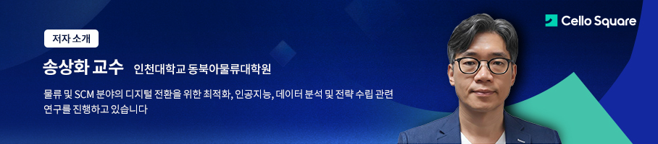

About the Author
Prof. Song Sang-hwa Graduate School of Logistics at Incheon National University
Conducting research on optimization, AI, data analysis, and strategy establishment for the digital transformation of logistics and SCM fields

